|  |
| --- |
| Title: Platform Aided Architecture for Machine Learning Operations (MLOps) for Engineering applications |

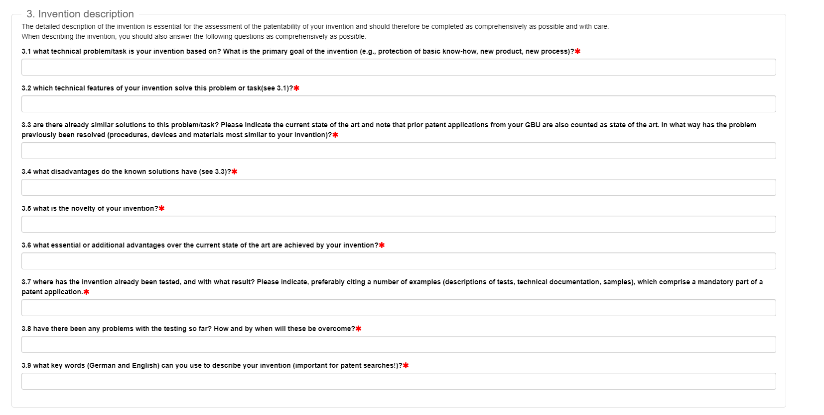

3.1 What technical problem/task is your invention base on? What is the primary goal of the invention (e.g., protection of basic know-how, new product, new process)?



Major Technical challenges,



3.2 Which technical features of your invention solve this problem or task?

3.3 Are there already similar solutions to this problem or task? Please indicate the current state of the art and note that prior art and note that prior patent application from your GBU is also counted as the art. In what way has the problem previously been resolved (procedure, devices, and materials most similar to your invention)?

Search for similar patents / Reference papers etc.

3.4 What disadvantages do the known solutions have?

Gaps in the identified State of the Art

**ADD Your idea in details with all the Flow diagram and block diagram explaining the technical details**

3.5 What is the novelty of your invention?

Explain briefly your idea and how do you overcome identified technical disadvantages mentioned previously

3.6 What essential or additional advantages over the current state of the art are archived by your invention?

Advantages or the benefits of your idea

3.7 Where has the invention already tested, and with what results? Please indicate, preferably citing a number of examples (descriptions of test, technical documentations, samples), which comprise a mandatory part of patent application.

3.8 Have there been any problems with the testing so far? How and by when will these be overcome?

3.9 What keywords (German and English) can you use to describe your invention (important for patent search)?

5.1 What application will this invention be used for? Which customer benefit occurs?

5.2 Have information, publications, deliveries or notifications been forwarded to third parties or is any of the above planned? Was an NDA completed beforehand

5.3 Other remarks or explanation regarding the invention

5.4 Please indicate the USP (Unique Selling Proposition) of your invention

5.5 Describe your invention using a maximum of three sentences, such that it can be understood by anyone.